The Tragedy of Flight

A Comprehensive Crash Analysis

Introduction:

The tragedy of flight, specifically air crashes, presents a significant business problem for the aviation industry. Air crashes can result in significant financial costs for airlines, manufacturers, and other businesses involved in the aviation industry. These costs may include the following:

Aircraft damage or destruction:

When an aircraft is involved in a crash, it may be damaged or destroyed, leading to significant repair or replacement costs for the airline or manufacturer.

Liability claims:

Air crashes can result in lawsuits and liability claims from passengers, their families, and other parties affected by the incident. These claims can result in significant financial settlements or judgments against the airline or manufacturer.

Loss of revenue:

Air crashes can lead to a loss of revenue for airlines, as passengers may avoid flying with the airline or may be unable to do so due to grounded flights or other disruptions.

Damage to reputation:

Air crashes can also damage the reputation of airlines and manufacturers, leading to a loss of customer trust and loyalty.

Purpose:

The purpose of the project is the aviation industry must continue to prioritize safety and invest in ongoing improvements to reduce the risk of air crashes. This may include implementing new technologies, improving training and education for pilots and other personnel, and conducting regular safety audits and inspections. By doing so, the industry can help prevent future tragedies while also protecting its financial interests.

Problem Definition & Design Thinking:

Empathy Map

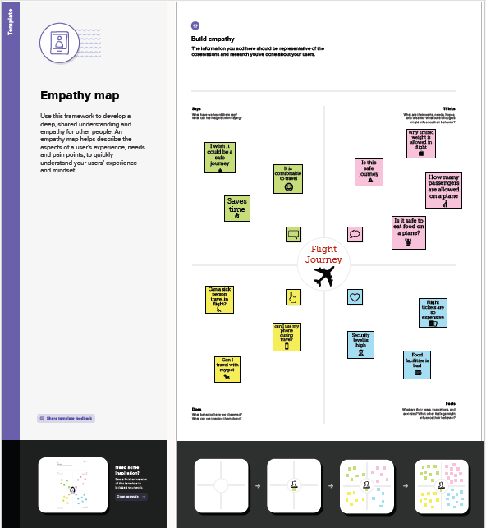

Brainstorming & Ideation

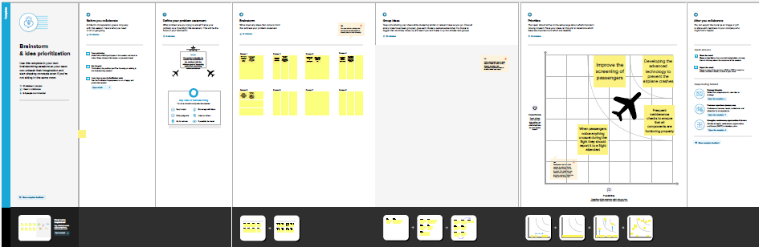

Result:

Comparing Aboard Vs. Fatalities Vs. Ground

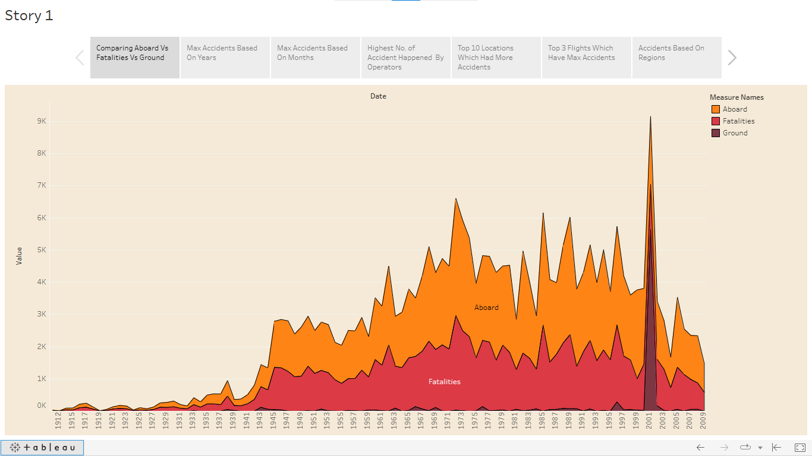

Maximum Accidents Based On Years

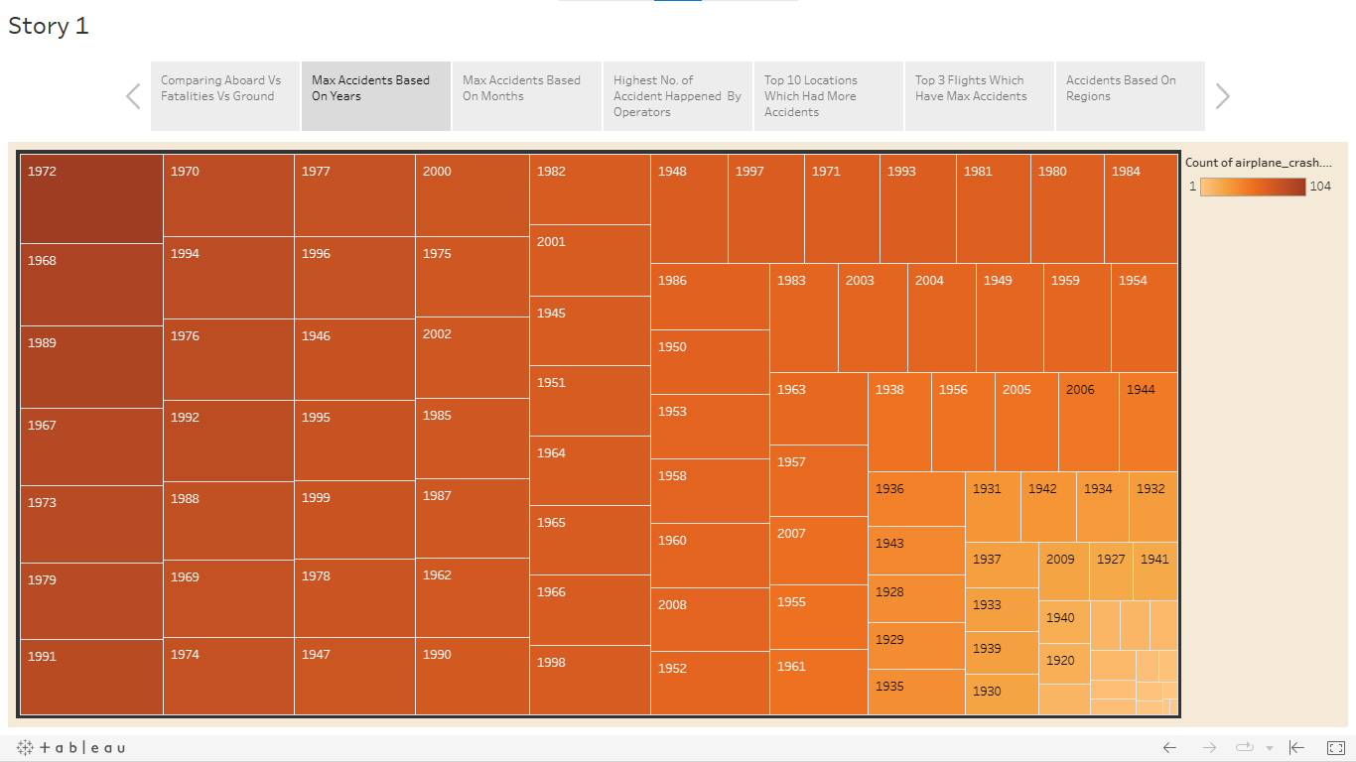

Maximum Accidents Based On Months

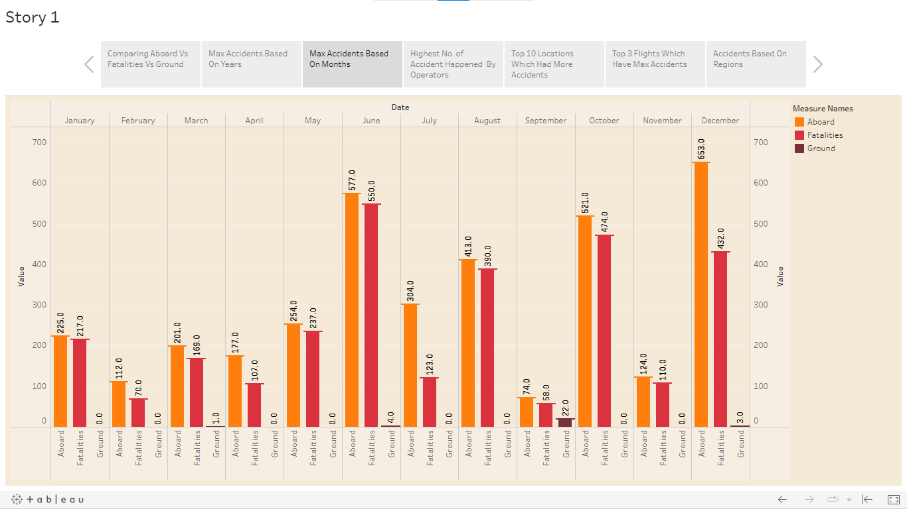

Highest Number of Accidents Happened By Operators

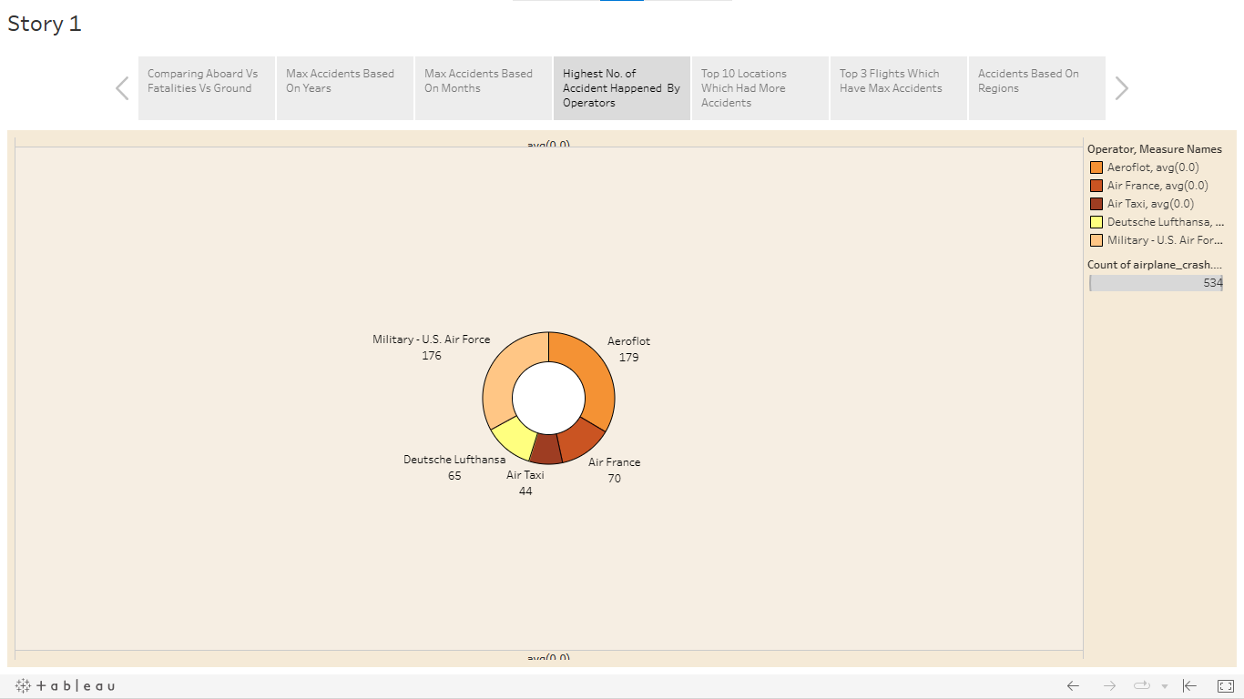

Top 10 Locations Which Had More Accidents

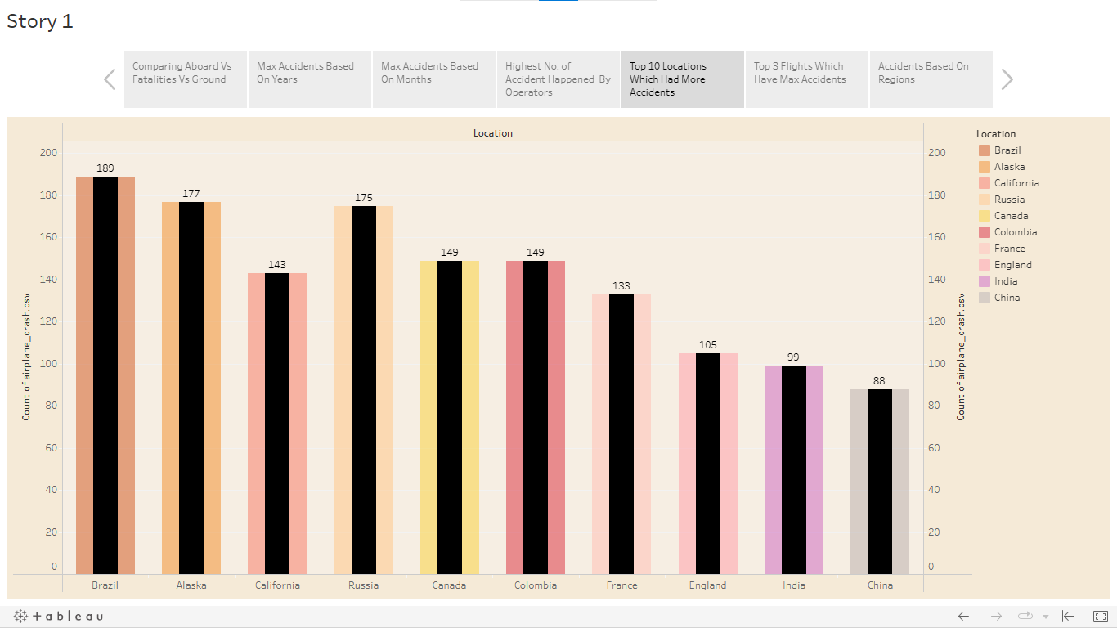

Top 3 Flights Which Have Maximum Accidents

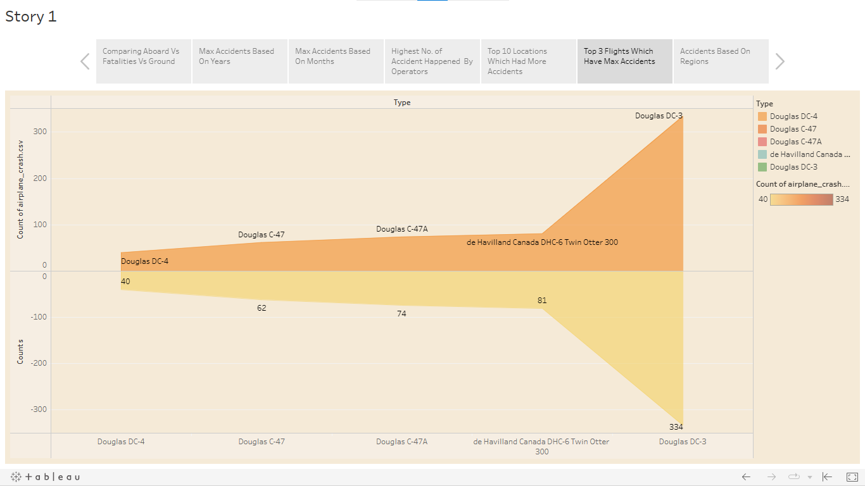

Accident Based On Regions

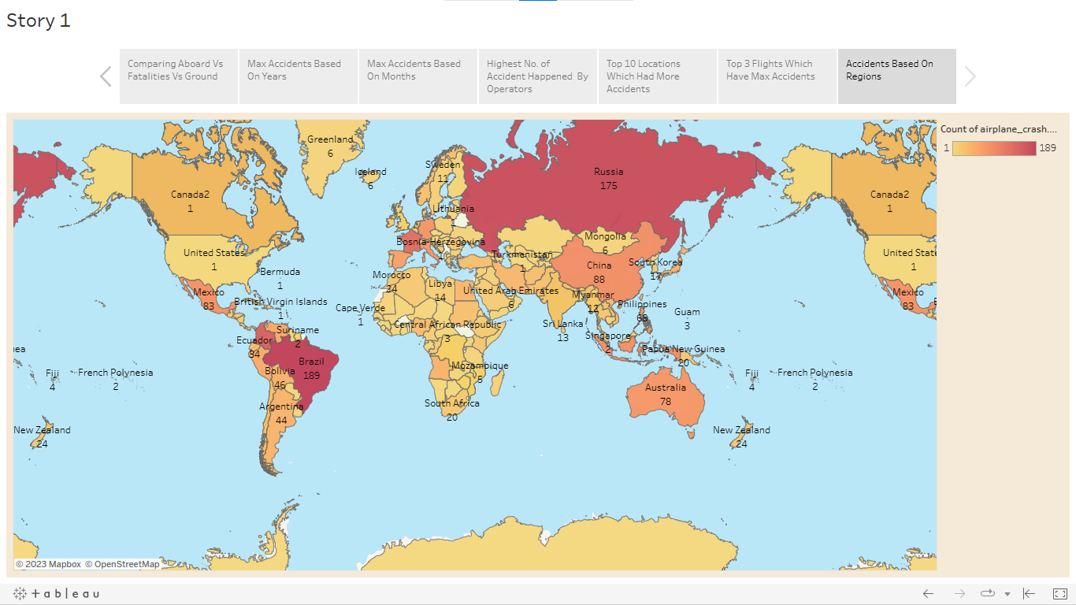

Dashboard 1

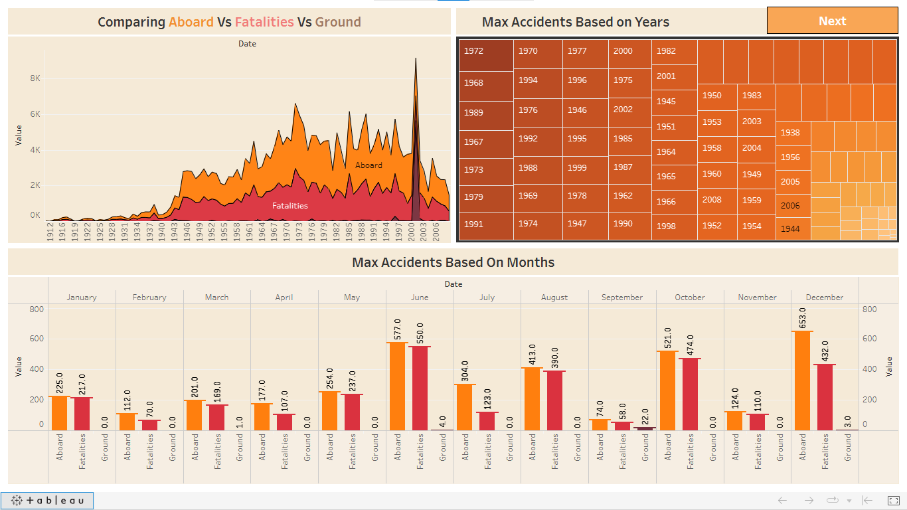

Dashboard 2

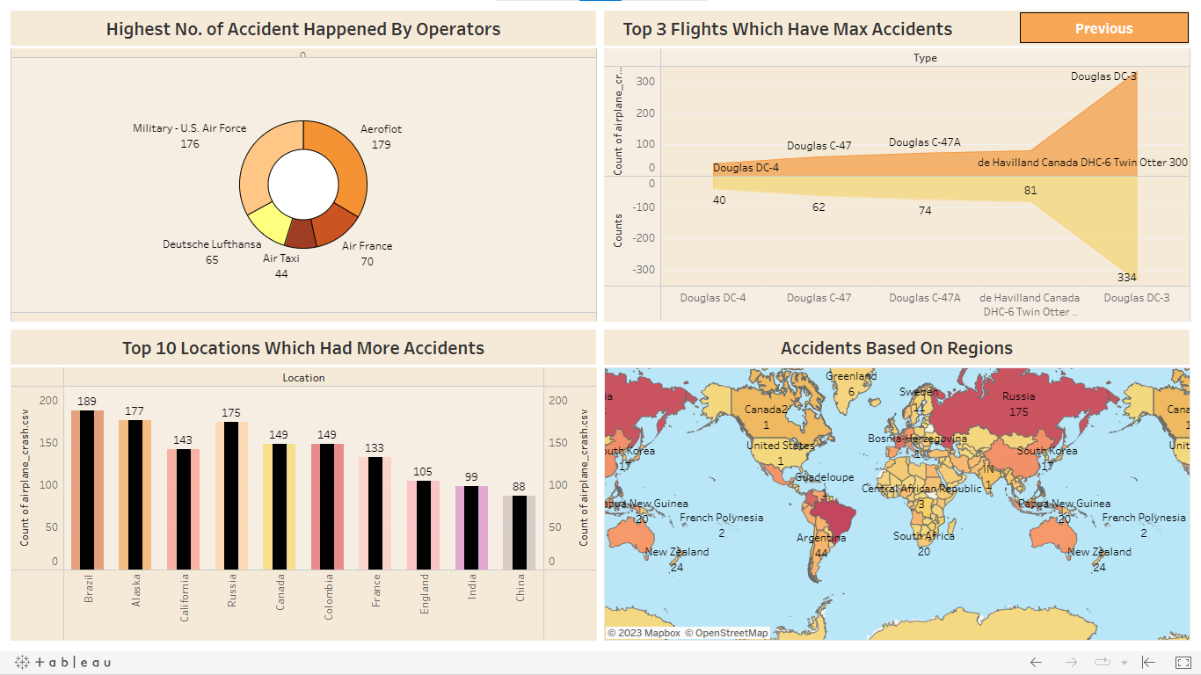

Advantages & Disadvantages:

Advantages:

1. Improved Safety: A proposal of air crashes helps to identify the root causes of accidents and suggests corrective measures to prevent future incidents. This can lead to improved safety standards in the aviation industry.

2. Improved Investigations: With a proposal of air crashes, investigations can be conducted more thoroughly, and all possible causes of an accident can be considered. This can lead to more accurate and reliable findings.

3. Improved Public Confidence: When the public sees that the aviation industry is taking steps to address safety concerns, they may have more confidence in flying, which could lead to increased air travel and revenue for airlines.

4. Improved Training: By analyzing the causes of accidents, airlines and aviation authorities can identify areas where pilots and other staff need more training, leading to a safer and more efficient industry.

Disadvantages:

1. Cost: Conducting a thorough investigation and implementing corrective measures can be expensive, and this cost may be passed on to consumers in the form of higher airfare prices.

2.Time-consuming: A proposal of air crashes can take a long time to complete, and in the meantime, airlines and aviation authorities may be hesitant to implement changes until the investigation is complete.

3. Blame and Liability: Investigations into air crashes may lead to accusations of blame and liability, which can result in legal battles and negative publicity for airlines and other stakeholders.

4. Data Availability: The quality and availability of data may be limited, making it difficult to identify the root causes of accidents accurately. Additionally, not all countries or airlines may be willing to share data, which can hinder investigations.

Applications:

There are a few different sectors of aviation, with three being the main pillars that uphold the aviation industry as a whole:

Commercial Aviation

General Aviation and

Military aviation.

Conclusion:

The aviation industry must continue to prioritize safety and invest in ongoing improvements to reduce the risk of air crashes. This may include implementing new technologies, improving training and education for pilots and other personnel, and conducting regular safety audits and inspections. By doing so, the industry can help prevent future tragedies while also protecting its financial interests.

Future Scope:

The aviation industry is a rapidly growing and constantly evolving sector that plays a vital role in the global economy. Here are some of the future scopes for the aviation industry:

1. Sustainable aviation: In the future, we can expect to see the use of alternative fuels and new technologies to reduce the environmental impact of air travel.

2. Technological advancements: We can expect to see new technologies like AI, machine learning, and block chain being implemented to enhance the safety, efficiency, and security of air travel.

3. Increased connectivity: The demand for air travel is expected to increase in the coming years. This will open up new markets and opportunities for the aviation industry.

4. Digital transformation: The aviation industry is undergoing a digital transformation, with the use of digital technologies like big data, cloud computing. This is expected to improve efficiency and reduce costs.

5. Autonomous aviation: With the development of autonomous technologies, we can expect to see the emergence of autonomous aviation in the future

Appendix:

Tableau Public Dashboard Link:

<https://public.tableau.com/views/TheTragedyOfFlightProjectDashboard/Dashboard1?:language=en-US&:display_count=n&:origin=viz_share_link>

Tableau Public Story Link:

<https://public.tableau.com/views/TheTragedyOfFlightProject-Story/Story1?:language=en-US&:display_count=n&:origin=viz_share_link>

Project link:

<file:///C:/Users/Karthik/Desktop/The%20Tragedy%20of%20Flight-%20A%20Comprehensive%20Analysis/The%20Tragedy%20of%20Flight%20-%20Project/index.html>

Video Link:

<https://drive.google.com/file/d/1K64icDx24MimcLeO3bkat1WbTi8y7dh3/view?usp=share_link>